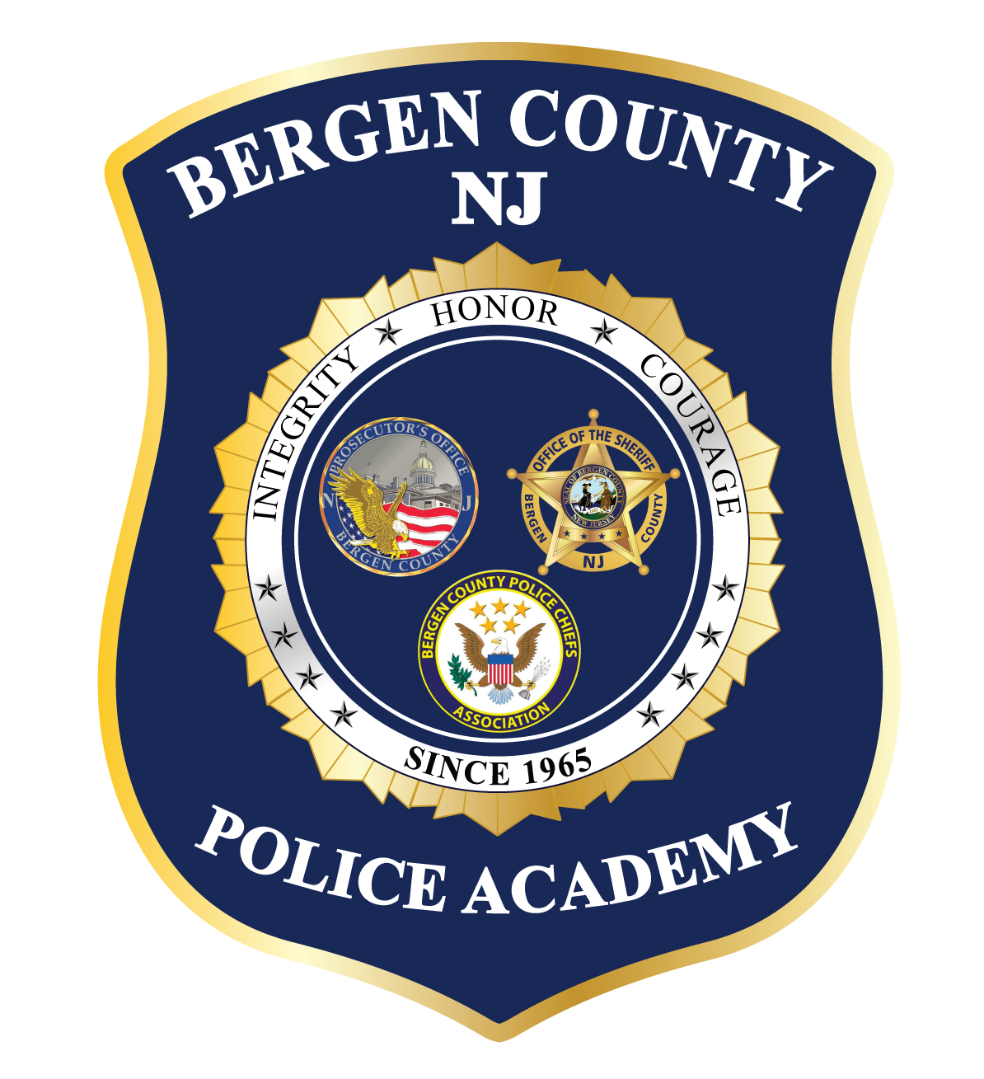

BASIC COURSE FOR POLICE OFFICERS
* * * * * * * * * * * * * * * * * * * * * * * * * * * * * * * * * * * * *

BCPO CLASS # 124

22 Weeks Orientation: Friday, January 17, 2020
First Day of Class: Monday, January 20, 2020
Graduation: Thursday, June 11, 2020

We offer a training course designed for the newly appointed police officer / sheriff’s officer, in accordance with the Police Training Act (52:17B-66 et seq.) and approved by the Police Training Commission, Department of Law and Public Safety and The State of New Jersey. Contents include the subjects of Professional Development, Criminal Justice System, Police Community Relations, Criminal Law, Legal requirements of Arrest – Search and Seizure, Evidence and Use of Force, Communications, Vehicle Operations, Emergency Medical Care, Unarmed Defense, Patrol Concepts, Traffic Control, Criminal Investigations and Physical Conditioning etc.

Prerequisite: Pursuant to P.T.C. Rule N.J.A.C. 13:1-8.1, a background investigation, medical evaluation with clearance, and the requisite agency training prior to graduation for all trainees enrolled is mandatory.

- Occupational Medical Center doctor’s medical certification, including a Bruce Protocol Stress Test, is required of all applicants. Contact Occupational Medical Center in Hackensack at (551)996-8670 for a medical examination/stress test appointment. Last day of appointments is Friday, January 3, 2020
- The mandatory pre-assessment physical fitness tests will be Tuesday, January 7, 2020 at 9am. This is an all-day event.
- Periodic drug screening of all recruit officers is conducted during the program. Confirmation of substance abuse will result in immediate dismissal.
- Valid New Jersey Driver’s License is required.

Agencies interested in enrolling a recruit in the Basic Course for Police Officers may send an e-mail to PoliceTraining@bcpo.net to reserve slots, and to receive a recruit information packet.

PROGRAM COST: $1,350.00 + $45 per drug test given

Basic Police Training Class # 125 - tentative
Orientation Day – Friday, July 17, 2020
Graduation - Thursday, December 10, 2020

